SIMATS ENGINEERING

ASSESSMENT TOOL 2
Course: Object Oriented Analysis and Design (CSA1110)
CO2: Design UML diagrams to represent system requirements and architecture (BL3)

Question 1: Use Case Diagram — Smart Hotel Reservation System
Analysis of Requirements
The Smart Hotel Reservation System involves two primary human actors — Guest and Manager — and two supporting external actors — Payment Service and Notification Service. The original description only mentioned basic actions (search, reserve, cancel, pay) without clearly separating actor responsibilities or showing reusable/optional behaviour. The following actors and use cases were identified after analysis:
Identified Actors
- Guest (primary actor): searches rooms, makes reservations, cancels bookings, makes payments, views booking history.
- Manager (primary actor): allocates rooms, generates reports, manages room inventory.
- Payment Service (external/secondary actor): completes the actual payment transaction.
- Notification Service (external/secondary actor): sends email/SMS confirmations.
Identified Use Cases and Relationships
- Login/Authenticate — common precondition, so it is <<include>>d by Make Reservation and Make Payment.
- Make Reservation <<include>> Process Payment — a reservation cannot be completed without payment being processed.
- Make Reservation <<include>> Send Confirmation, and Cancel Booking <<include>> Send Confirmation — every booking action ends with a notification.
- Make Payment <<extend>> Apply Discount/Offer — discount application is optional, only triggered under certain conditions (extension point).
- Process Payment communicates with the external Payment Service actor; Send Confirmation communicates with the external Notification Service actor.
This design clarifies actor boundaries — the Guest performs self-service actions, the Manager performs administrative actions, and external systems are modelled separately from human actors, improving system clarity as required by the case study.
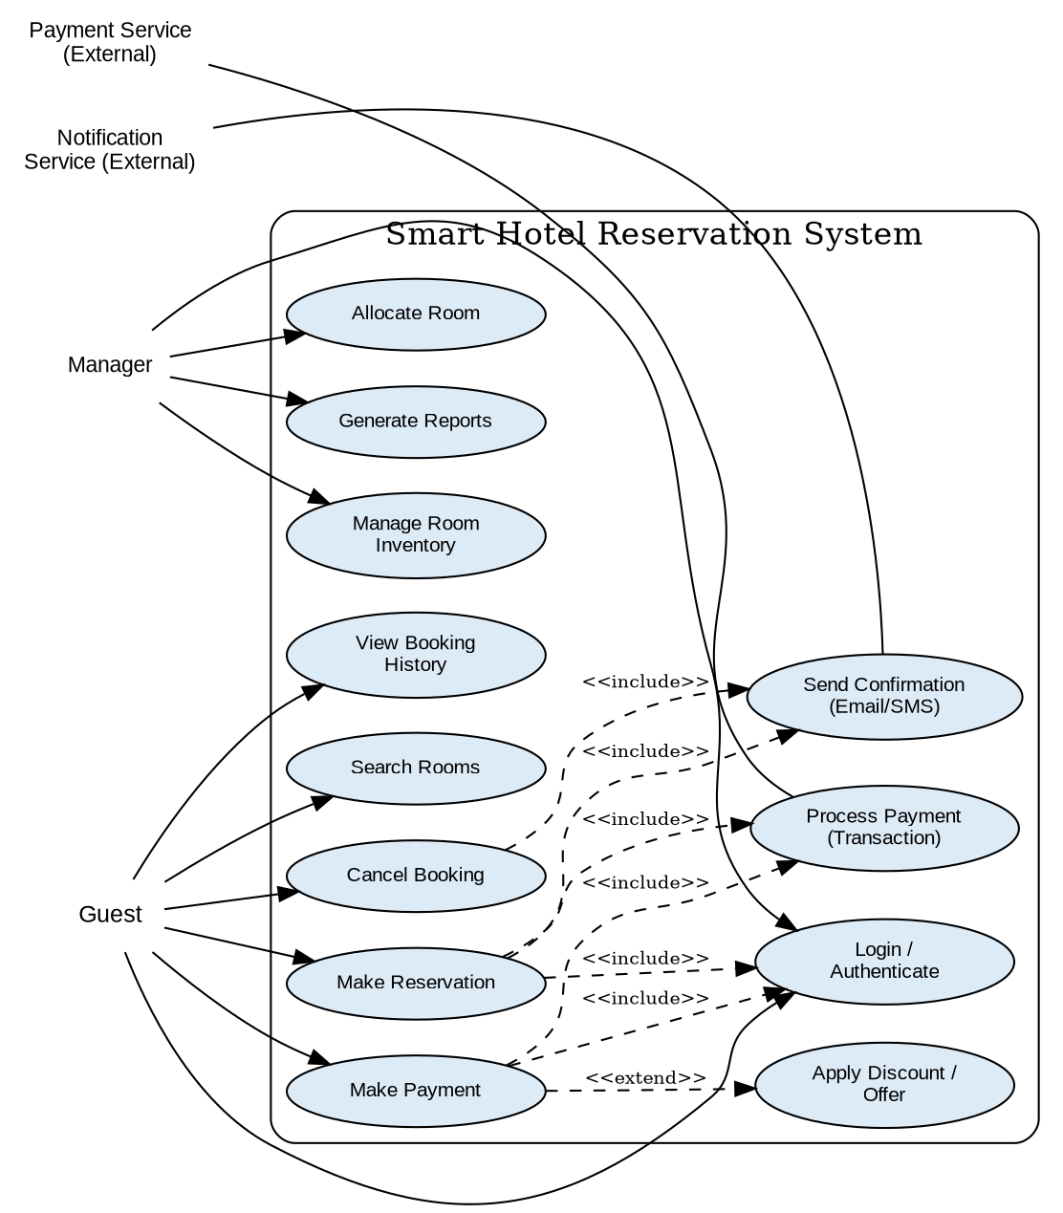
Figure 1: Use Case Diagram — Smart Hotel Reservation System

Question 2: Class Diagram — University Management System
Analysis of Requirements
The University Management System requires modelling of Student, Faculty, Course, Department and Examination entities, along with their attributes, operations and relationships. Student and Faculty share common properties (identity, contact details), which is best modelled using generalization from an abstract Person superclass. Department owns Faculty and Course (aggregation), Course owns Examination (composition/aggregation), and Student–Course is a many-to-many association (enrolment).
Identified Classes
- Person (abstract superclass): personId, name, dob, email, phone; getDetails(), updateContact().
- Student (inherits Person): rollNo, program, year, cgpa; enrollCourse(), viewResult(), payFees().
- Faculty (inherits Person): empId, designation, specialization; assignCourse(), evaluateExam(), uploadResult().
- Department: deptId, deptName, headOfDept; addFaculty(), addCourse().
- Course: courseId, courseName, credits, semester; getSyllabus(), addExamination().
- Examination: examId, examDate, examType, maxMarks; scheduleExam(), publishResult().
- Result: resultId, marksObtained, grade; calculateGrade().
Identified Relationships
- Generalization: Student and Faculty inherit from Person.
- Aggregation: Department aggregates Faculty (1..*) and Course (1..*).
- Association: Faculty teaches Course (1..*); Student enrolls in Course (many-to-many).
- Aggregation: Course has Examination (1..*).
- Association: Student and Examination each produce Result (1..*).
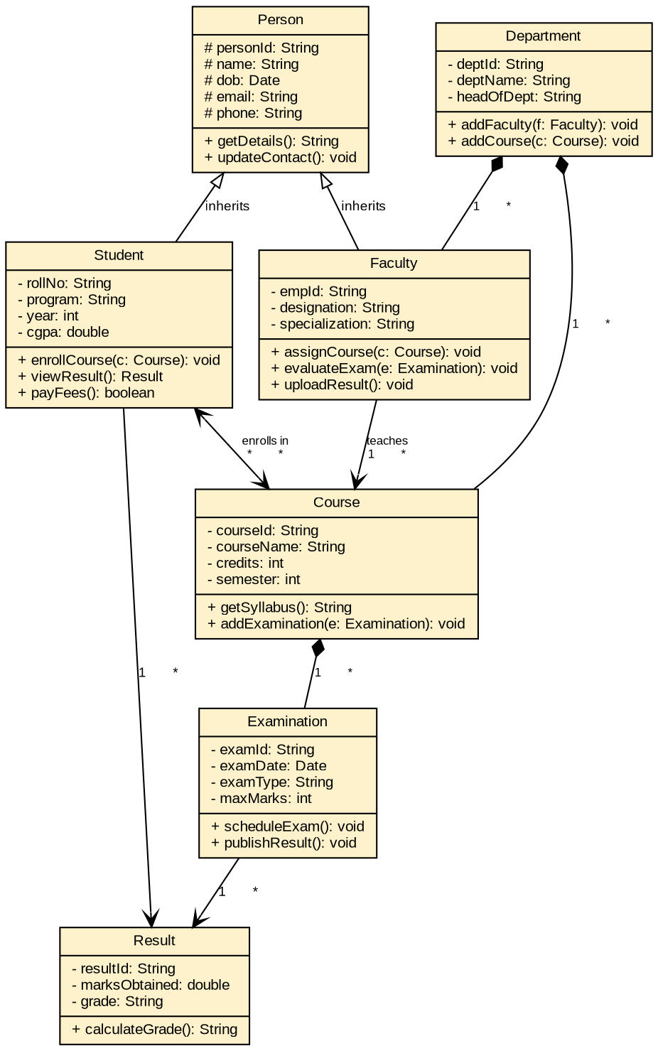
Figure 2: Class Diagram — University Management System

Question 3: Sequence Diagram — Vehicle Rental System
Analysis of Process Flow
The original description only stated that a customer searches, books, pays, and receives confirmation, without specifying the objects that collaborate internally. Analysis of the workflow reveals the need for a UI/Controller boundary object, a VehicleCatalog entity, a BookingManager control object, a Booking entity, and two external systems — PaymentGateway and Notification service. The complete, ordered interaction is shown below.
Identified Objects and Message Sequence
- Customer -> UI: searchVehicle(criteria); UI -> VehicleCatalog: findAvailable(criteria); return vehicleList.
- Customer -> UI: selectVehicle(vehicleId); UI -> BookingManager: createBooking(customer, vehicle).
- BookingManager -> VehicleCatalog: checkAvailability(); BookingManager -> Booking: new Booking() (object creation).
- UI -> Customer: promptPayment; Customer -> UI: makePayment(details); UI -> PaymentGateway: processPayment(amount).
- UI -> BookingManager: confirmBooking(bookingId); BookingManager -> Booking: updateStatus(CONFIRMED).
- BookingManager -> Notification: sendConfirmation(); Notification -> Customer: rentalConfirmation.
Dashed return arrows represent reply messages, and solid arrows represent synchronous calls, in line with standard UML sequence diagram notation.
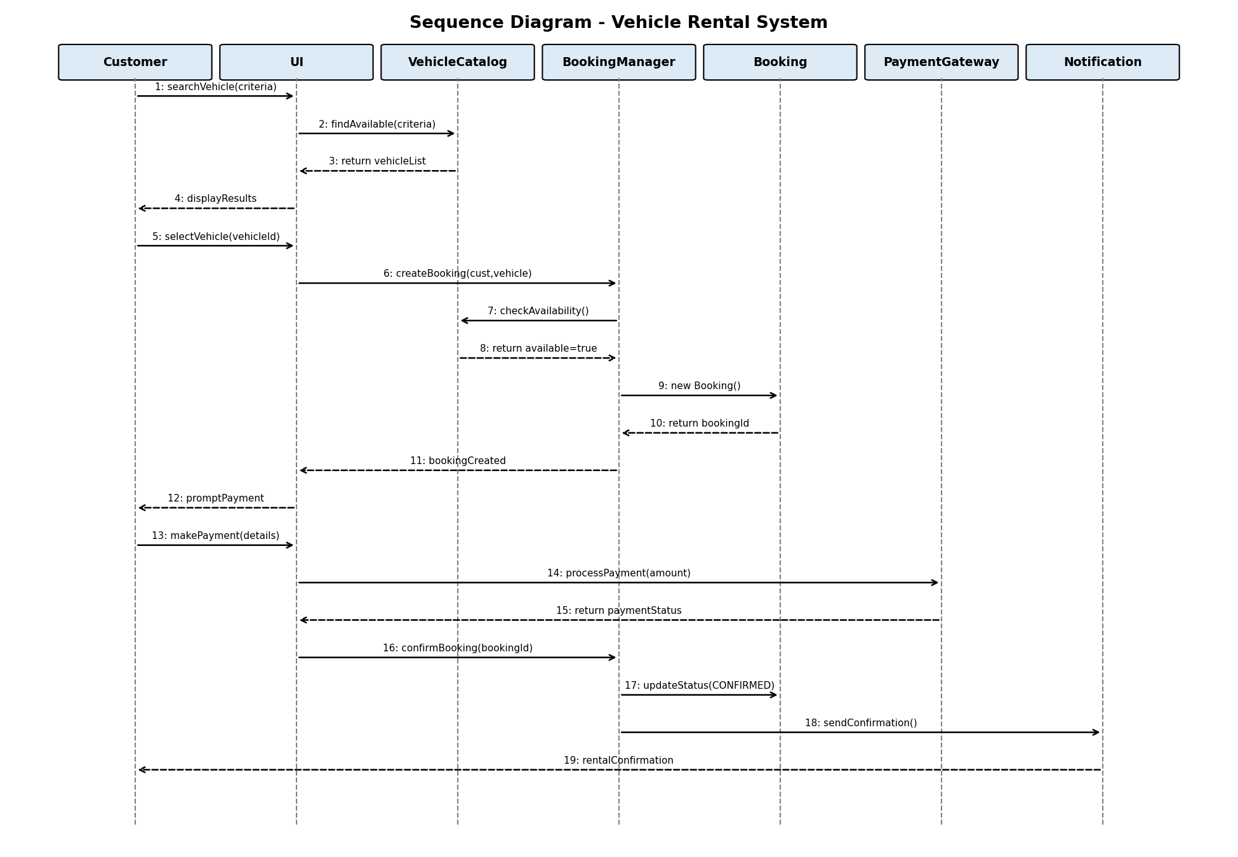
Figure 3: Sequence Diagram — Vehicle Rental System

Question 4: State Transition Diagram — Traffic Signal Control System
Analysis of System Behaviour
The traffic signal cycles normally through Red -> Green -> Yellow -> Red on timer expiry. Two special conditions interrupt the normal cycle from any state: an emergency vehicle detection (Emergency Mode) and a maintenance request (Maintenance Mode). Both exceptional states return to Red Signal once cleared/completed, restarting the normal cycle.
Identified States, Events and Transitions
- Initial state -> Red Signal (default state on system start).
- Red Signal --timer expires / switchToGreen()--> Green Signal
- Green Signal --timer expires / switchToYellow()--> Yellow Signal
- Yellow Signal --timer expires / switchToRed()--> Red Signal
- Red/Green/Yellow --emergencyVehicleDetected--> Emergency Mode; Emergency Mode --emergencyCleared / resumeCycle()--> Red Signal
- Red/Green/Yellow --maintenanceRequest--> Maintenance Mode; Maintenance Mode --maintenanceComplete / restartCycle()--> Red Signal
This ensures every state and guard condition mentioned in the case study is represented, and that the system always returns to a safe, well-defined state (Red Signal) after an interruption.
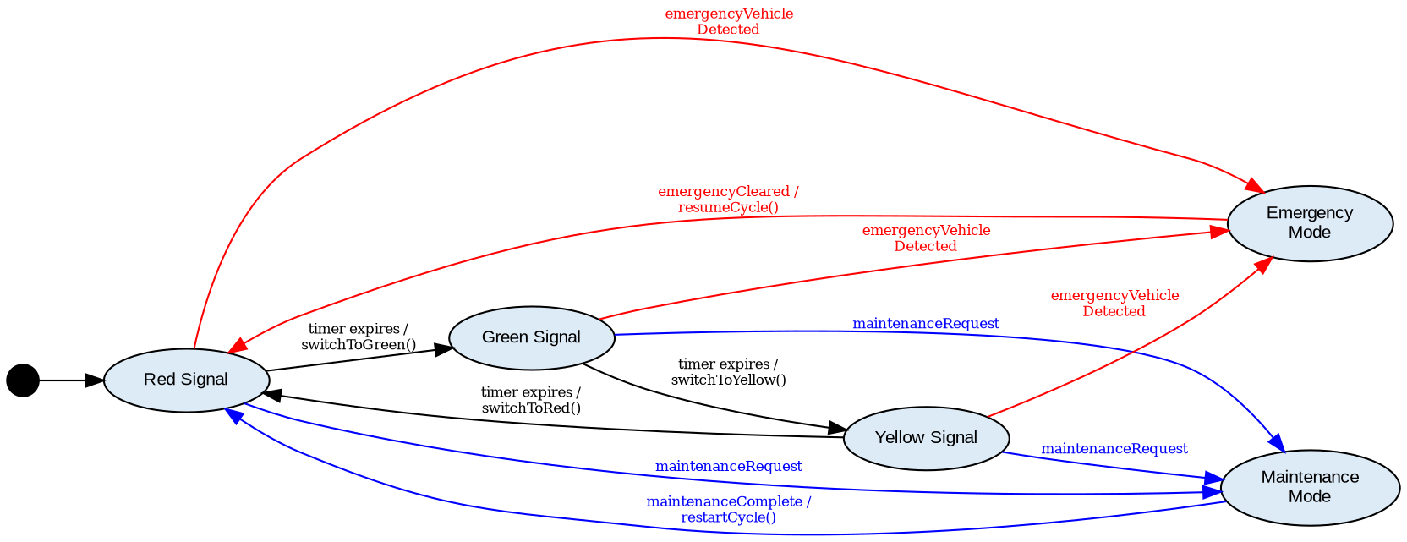
Figure 4: State Transition Diagram — Traffic Signal Control System

Question 5: Component Diagram — Smart Healthcare Portal
Analysis of System Architecture
The Smart Healthcare Portal is decomposed into five functional components plus two supporting components identified during analysis (API Gateway and Authentication & Access Control), and a shared Database Service. Each component exposes provided interfaces (lollipop notation) consumed by other components, clarifying dependencies that were previously undocumented.
Identified Components and Interfaces
- API Gateway: single entry point, routes requests to Patient Management, Appointment Scheduling and Billing; depends on Authentication & Access Control (<<use>>).
- Patient Management: exposes IPatientLookup / IPatientService, used by Appointment Scheduling, Medical Records and Billing.
- Appointment Scheduling: exposes IAppointmentService/IAppointmentInfo; depends on IPatientLookup and triggers Medical Records (ICreateVisitRecord) and Notification Services (INotify).
- Medical Records: depends on IPatientLookup from Patient Management; stores/retrieves data from the Database Service.
- Billing: exposes IBillingService; depends on IPatientLookup and IAppointmentInfo; triggers Notification Services (IInvoiceAlert).
- Notification Services: sends alerts/reminders triggered by Appointment Scheduling and Billing.
- Database Service: shared persistence component used by Patient Management, Appointment Scheduling, Medical Records and Billing.
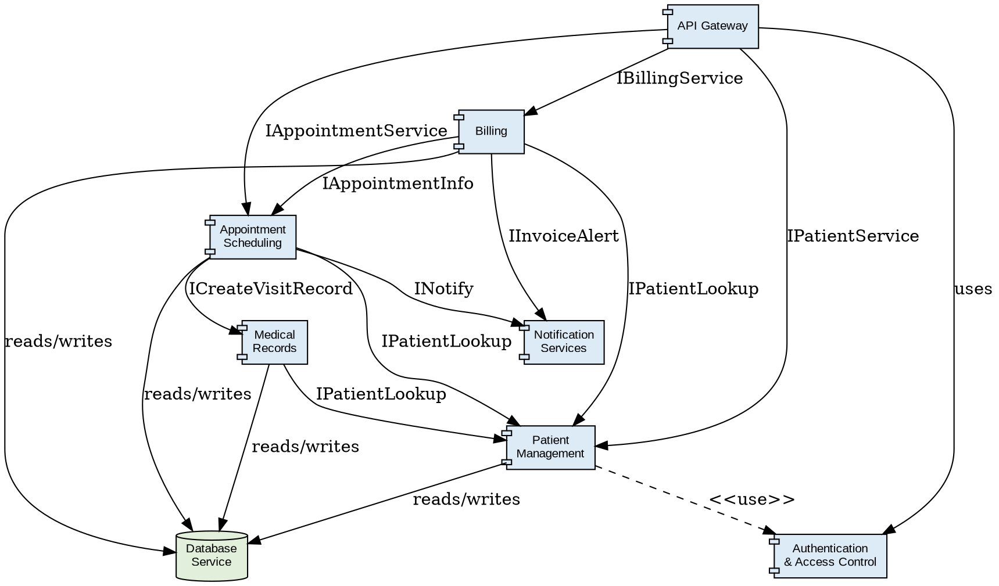
Figure 5: Component Diagram — Smart Healthcare Portal

Question 6: Deployment Diagram — Smart City Waste Management System
Analysis of Deployment Environment
The physical architecture spans four tiers: edge-level IoT sensor nodes, an intermediate edge gateway, a cloud server hosting the application and database, and client-side monitoring dashboards. Communication protocols were identified for each link to clarify integration, which was missing from the original design.
Identified Nodes, Artifacts and Communication Paths
- <<device>> IoT Waste-Bin Sensor Node — deploys SensorFirmware artifact; sends fill-level/status data.
- <<device>> Edge Gateway Device — deploys EdgeProcessing.jar artifact; aggregates and pre-processes sensor data; communicates with sensor nodes via TCP/MQTT.
- <<execution environment>> Cloud Server (AWS) — contains two nested server nodes: an Application Server deploying WasteMgmtAPI.war, and a Database Server hosting the WasteDB artifact; connected via HTTPS/REST from the edge gateway, and JDBC internally to the database.
- <<device>> Monitoring Dashboard (Client Browser) — deploys DashboardWebApp artifact; receives live updates from the Application Server via HTTPS/WebSocket.
This deployment view shows both the physical nodes (devices, execution environments, servers) and the software artifacts deployed on each node, together with the communication links and protocols connecting them, satisfying the requirement for a complete system architecture representation.
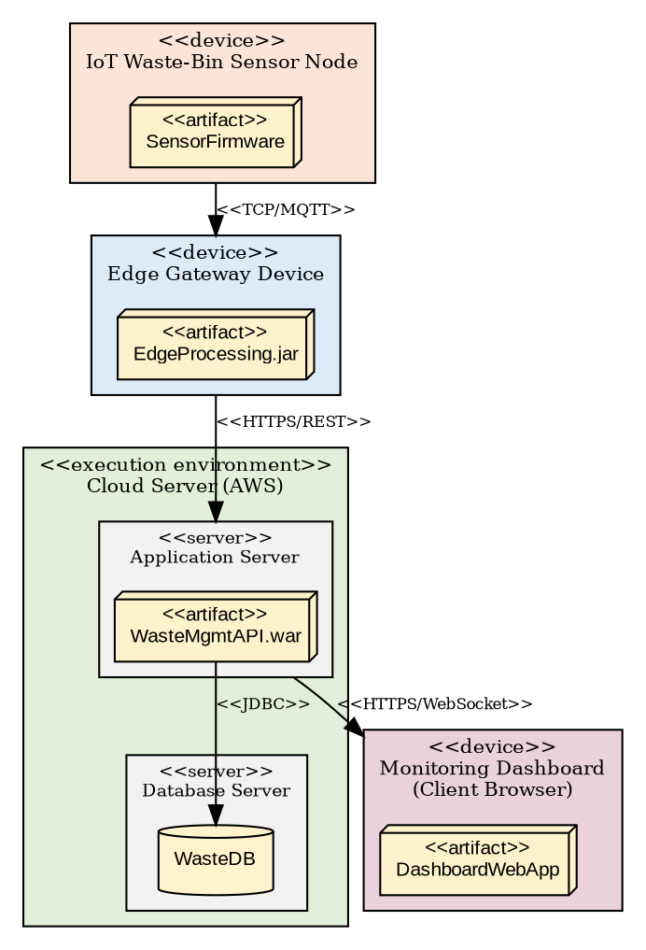
Figure 6: Deployment Diagram — Smart City Waste Management System

